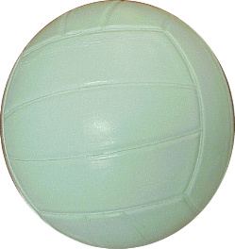

PANTHERS

IROQUOIS VOLLEYBALL TRY-OUT DATES:
Day | Date | Time
Wednesday | 9/4/24 | 2:50-5:00
Thursday | 9/5/24 | 2:50-5:00
Friday | 9/6/24 | 2:50-5:15
You should attend ALL tryout dates!
Tryouts will be closed to the public!
* If possible, please wear a shirt with your last name on the back. If you don’t have one, don’t worry, we can write it on a piece of tape.

To try-out for the 7th/8th grade volleyball team, you MUST have a physical dated April 15, 2024, or later. NO EXCEPTIONS!
If you do not have a physical on file, I have attached a form. You may also access the form online at: http://www.chippewavalleyschools.org/athletics/

If You Make the Team
Please understand that we will have practice every day after school from 2:50-4:30. All athletes must have a ride home after practice. Carpooling is always helpful and a great idea.
Games will be played on Mondays and Thursdays, unless otherwise specified. The 7th grade games begin at 3:30 and 8th grade games immediately follow, which is usually around 4:45.

In addition, if you make the team, you will have to fill out and sign the Code-of-Conduct form. Information can be found at: http://www.chippewavalleyschools.org/athletics.asp

We look forward to seeing all of you at try-outs! A great way to work on your basic volleyball skills is to attend volleyball camps during the summer or get involved with a volleyball club. Below are a few club websites for you to visit.
https://www.mielite.com/ http://www.crankitvolleyball.com/
https://www.legacyvolleyballcenter.com/ http://www.monstersvolleyball.com/
https://unifiedvolleyball.com/ https://www.glvbc.com/

~ Coach Hollie George (8th grade) ~ Coach Sheila Corbin (7th grade)
Email: HGeorge@cvs.k12.mi.us Email: SCorbin@cvs.k12.mi.us

